Ivan | M 079 922 9061
 | 5 Lake View Lane
Copeland | Muizenberg
Copeland | ivan.copeland2015@gmail.com
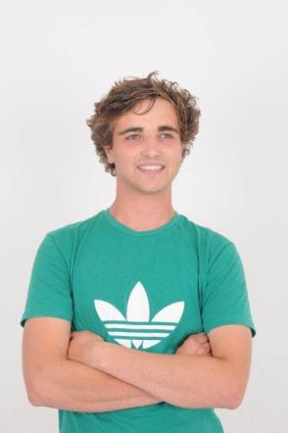

Profile

Experience

Modelling Work

Model work for commercials and photo shoots.

April 2010 - August 2012

T-shirt Business

Created and sold original design T-shirts both personally and stocked in store.

2011

Organic Market

Grew and sold organic vegetables locally.

2013

Freelance Work

Created animated videos for Eco Safety (Health & Safety Business) for a 3 month

period.

2013

Delivery Extreme

Food delivery.

November 2013 - March 2014

Espresson.Kom

Barista for local coffee shop in Kommetjie.

January 2015 - April 2015.

Education Primary School Education:

Mc Gregor Waldorf (2002 - 2005)

Imhoff Waldorf (2005 - 2007)

Secondary School Education:

Constantia Waldorf (2007 - 2009)

Valley Tutor Centre (2010 - 2013)

Highest grade passed: IGCSE as well as some AS Levels, currently studying towards the

remaining needed for Tertiary Education.

Subjects passed:

English (IGCSE & AS Level)

Physics (IGCSE & AS Level)

Mathematics (IGCSE)

Business Studies (IGCSE)

Information & Communication Technology (IGCSE)

Biology (IGCSE)

Physics (IGCSE)

Currently I am part time studying my Chemistry in AS Level in order for me to study Engineering.

 | ________________________________________________________________________________
Skills | I like working with people, I am excellent at Maths and good with children as I have
 | many younger siblings. I believe I am reliable, diligent and can show initiative in a
 | working environment.
 | My interests are gardening, being creative and spoken word. I plan on attending UCT
 | to study Engineering and am currently looking for part time employment whilst I
 | complete my AS levels in Chemistry.
References | Delivery Extreme:
 | Ryan Emerood, Manager (Tel no: 021 - 671 2624)
 | Espresson.Kom:
 | Carol, Owner (Tel no: 021 – 783 0342)

